Voting Laws Essay
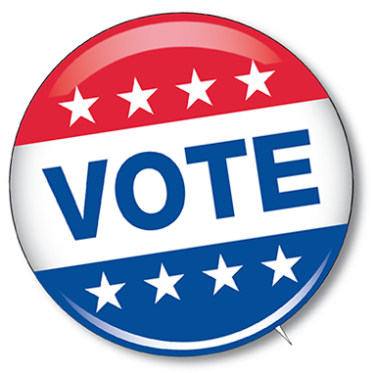
Essay Topic: Based on the information we have learned on Jim Crow laws, and new voting ID laws today, in your opinion, have we made progress in providing all Americans the right to vote? Are we repeating history?

Be sure to include:
-Information on Jim Crow Laws
-Information on today’s voter ID laws
-A critique of where we are today in comparison to the past

Compare and Contrast
-The Issues
-The States
-Those Affected
-The Lawmakers

